Software Requirements Specification
Collaborative Study Material & Quiz Platform
Project #21 | Version 1.0 | 28-09-2026
Project | Collaborative Study Material & Quiz Platform (Project #21)
Version | 1.0
Authors | Kruthika C B (PES1UG24CS670), Narendra Kanchi (PES1UG24CS678), Mohammed Al Zubed Hulgeri (PES1UG24CS674)
Date | 28-09-2026
Status | Draft for Part-1 submission
Format | IEEE-style SRS (IEEE 830 / ISO/IEC/IEEE 29148 structure), following the course SRS template
Revision history
Version | Date | Author | Change summary | Approval
1.0 | 28-09-2026 | Kruthika C B | First complete SRS with diagrams embedded
Approvals
Role | Name | Signature / Email | Date
Course Coordinator
Project Team Lead
Table of Contents
1. Introduction 3
1.1 Purpose 3
1.2 Scope 3
1.3 Audience 3
1.4 Definitions 3
1.5 Conventions 4
1.6 References 4
1.7 Document overview 4
2. Overall description 4
2.1 Product perspective 4
2.2 Major product functions (detailed) 4
2.3 User roles and characteristics (expanded) 4
2.4 Operating environment 5
2.5 Constraints 5
2.6 Assumptions and dependencies 5
3. External interface requirements 5
3.1 User interfaces 5
3.2 Hardware interfaces 6
3.3 Software interfaces 6
3.4 Communications 6
4. System features (detailed) 7
4.1 Authentication and access control 7
4.2 Material sharing 8
4.3 Question bank 8
4.4 Quiz 9
4.5 Performance analysis 10
4.6 Administration and moderation 10
5. Non-functional requirements (detailed) 10
5.1 Security 11
5.1.1 Security objectives 11
5.1.2 Security requirements 11
6. Quality attributes & Acceptance tests 13
7. System models and diagrams 13
7.1 UML Use-Case diagram 13
8. Requirements Traceability Matrix (RTM) 16

1. Introduction

1.1 Purpose
This document is a Software Requirements Specification (SRS) for the Collaborative Study Material & Quiz Platform. It defines the functional and non-functional requirements, interfaces, security requirements and verification criteria of the system. It is written for the development team, the testers and the course evaluators, and is the reference for the Test Plan and the Software Architecture & Design Specification.

1.2 Scope
The system is a web application built on the MERN stack (MongoDB, Express.js, React, Node.js). It covers registration and login with roles, sharing of study material (upload, search, download), a shared question bank, quiz creation and timed quiz attempts with automatic grading, performance reports for students and contributors, and moderation by an administrator.
It excludes live classes, video lectures, chat, payments, a native mobile app, grading of written answers, and checking of uploaded material for copyright or plagiarism.

1.3 Audience
Developers, QA engineers (testers), the course instructor and assessment evaluators, and the administrator who will run the system.

1.4 Definitions
List of acronyms: SRS, FR, NFR, SR, SO, UC, MERN, UI, API, REST, JWT, HTTPS, TLS, MCQ, RTM.

Term | Meaning
SRS | Software Requirements Specification (this document)
FR / NFR | Functional Requirement / Non-Functional Requirement
SR / SO | Security Requirement / Security Objective
UC | Use Case
MERN | MongoDB, Express.js, React, Node.js – the technology stack used
UI | User Interface
API / REST | Application Programming Interface; REST is a common style of web API that uses HTTP
JWT | JSON Web Token – a signed token that proves a user is logged in
HTTPS / TLS | Secure web connection; TLS is the encryption used by HTTPS
bcrypt | A method that turns a password into a scrambled value (hash) that cannot be reversed
MCQ | Multiple-Choice Question
RTM | Requirements Traceability Matrix (Section 8)
Student / Contributor / Admin | The three user roles described in Section 2.3
Study material | A file (PDF, DOCX or PPTX) uploaded by a Contributor for others to read
Question bank | The shared collection of all questions added by Contributors
Quiz / Attempt | A timed set of 5 to 50 questions / one complete try of a quiz by a Student
Response time | Time from the user’s action (click or submit) until the result is shown on the screen
ID scheme | CSQ-F-### functional, CSQ-NF-### non-functional, CSQ-SO-## security objective, CSQ-SR-### security requirement, UC-## use case, TC-xxx-## test case, DS-xxx-## design specification section

1.5 Conventions
- “shall” means the requirement is mandatory.
- Each requirement is written to be clear, unambiguous, concise and measurable: it uses “shall” and gives numbers wherever a quality is involved, so it can be tested.
- Priority: High = the system is unusable without it; Medium = important; Low = desirable.
- Identifiers follow the ID scheme in the table above (for example CSQ-F-001 for a functional requirement).

1.6 References
[1] IEEE Std 830-1998, IEEE Recommended Practice for Software Requirements Specifications.
[2] ISO/IEC/IEEE 29148:2018, Systems and software engineering — Life cycle processes — Requirements engineering.
[3] SRS Template for SE (course model SRS), provided by the instructor.
[4] Software Engineering Mini-Project Deliverables Part-1, due 28 September 2026.
[5] Test Plan and Software Architecture & Design Specification of this project (companion Part-1 documents, linked through Section 8).

1.7 Document overview
Section 2 gives an overall description of the product, its users and its constraints. Section 3 lists the external interfaces. Sections 4 and 5 contain the functional, non-functional and security requirements, each with acceptance criteria and a test case reference. Section 6 summarises the quality targets and the acceptance exit criteria. Section 7 holds the UML use case diagrams. Section 8 is the Requirements Traceability Matrix that links every requirement to the design and to the test cases.

2. Overall description

2.1 Product perspective
The platform is a new, self-contained web application. It consists of a React web client running in the user’s browser, a Node.js/Express.js server that provides a REST API and enforces all rules, a MongoDB database for records, and a file store on the server for uploaded material. It does not depend on any external system.

2.2 Major product functions (detailed)
- Register, log in and log out; role-based access (Student, Contributor, Admin)
- Upload study material with title, subject and topic
- Search and download study material
- Add, edit, delete, tag (topic, difficulty) and filter multiple-choice questions
- Create, publish and delete own quizzes from the question bank
- Attempt quizzes with a countdown timer
- Automatic grading and instant results with correct answers
- Performance reports: personal and topic-wise scores for Students, quiz statistics for Contributors
- Administration: remove inappropriate materials and quizzes

2.3 User roles and characteristics (expanded)
- Student: school or college learner; basic web skills; wants quick search, fair timed quizzes and clear feedback. Largest user group.
- Contributor / Teacher: teacher or senior student who creates content; basic web skills; wants to upload and organise material and questions quickly and see how students perform.
- Admin: very few users; moderate technical skill; keeps the platform clean and safe. Admin accounts are created during system setup, never through public registration.
Table 1: Role permissions (used by CSQ-F-003)
Feature | Student | Contributor | Admin
Register, log in, log out | Yes | Yes | Log in / out only
Search and download material | Yes | Yes | Yes
Upload material | No | Yes | No
Add, edit, delete own questions | No | Yes | No
Create, publish and delete own quiz | No | Yes | No
Attempt quiz | Yes | No | No
View own performance | Yes | No | No
View statistics of own quizzes | No | Yes | No
Remove materials and quizzes | No | No | Yes

2.4 Operating environment
- Client: latest two versions of Chrome, Firefox, Edge or Safari on Windows, macOS, Linux, Android or iOS.
- Server: Node.js 20 LTS or newer on Linux or Windows, with at least 50 GB of free storage.
- Database: MongoDB 6.0 or newer.
- Network: internet connection; all timings in this document are measured on a 10 Mbps connection.

2.5 Constraints
- The system must use the MERN stack, as given in the project topic.
- The browser and server communicate through a REST API using JSON.
- Uploaded files are limited to PDF, DOCX and PPTX, maximum 20 MB each.
- Only multiple-choice questions with four options and one correct answer are supported.
- The user interface language is English; only free and open-source tools may be used.

2.6 Assumptions and dependencies
Assumptions
- Every user has one personal email address that serves as the unique account identity.
- There is no negative marking: a correct answer gives 1 mark, any other answer gives 0.
- A Student may attempt a quiz more than once; each attempt is stored separately.
- Contributors are responsible for having the right to share what they upload.
Dependencies
- HTTPS needs a valid TLS certificate for the server (CSQ-SR-005).
- The server needs Node.js 20 LTS or newer and MongoDB 6.0 or newer (Section 2.4).
- All timing targets assume a 10 Mbps connection (Section 2.4).

3. External interface requirements

3.1 User interfaces
The primary UI is a responsive web interface with these pages: Register/Login, Home and Search, Material Details, Upload Material, Question Bank, Quiz Builder, Quiz Attempt, Quiz Result, Performance Dashboard and Admin Panel.
- The navigation menu shows only the options allowed for the logged-in role.
- Error messages use plain language and tell the user what to do next.
- The countdown timer is always visible on the Quiz Attempt page.
- Accessibility: all form fields have text labels, the pages can be used with the keyboard alone, and text has sufficient contrast.

3.2 Hardware interfaces
- No special hardware is required by users: a computer, tablet or phone with a screen and keyboard or touch input.
- The server needs disk storage for the database and uploaded files.

3.3 Software interfaces
- MongoDB database – stores users, materials, questions, quizzes and attempts.
- Server file store – stores uploaded material files.
- Web browser – runs the React client and connects to the REST API.
- Libraries – bcrypt (password hashing), JSON Web Token (sessions) and a file-upload library.

3.4 Communications
- HTTPS with TLS 1.2 or higher for all traffic between browser and server (CSQ-SR-005).
- Data is exchanged as JSON through the REST API; the API is defined in the Software Architecture & Design Specification.

4. System features (detailed)
Each requirement below includes acceptance criteria and a reference test case. IDs follow CSQ-F-###.

4.1 Authentication and access control
Description: Register users, authenticate them, end sessions and allow each user to use only the features of their role.
Req ID | Requirement | Type | Priority | Source / Stakeholder | Acceptance criteria / Test case ref | Comments / Dependencies
CSQ-F-001 | The system shall allow a visitor to register as a Student or Contributor by entering a name (2–50 characters), a unique email address and a password, and shall create the account within 3 seconds of submission. | Functional | High | All users | AC-CSQ-F-001: Valid details create the account within 3 s; an email that is already registered is rejected with “Email already registered”.  Test: TC-Auth-01 | Admin role cannot be chosen at registration. Uses MongoDB.
CSQ-F-002 | The system shall allow a registered user to log in with email and password, and shall display the message “Invalid email or password” when the credentials are wrong. | Functional | High | All users | AC-CSQ-F-002: Correct credentials open the home page of the user’s role; wrong credentials show the message and create no session.  Test: TC-Auth-02 | Related: CSQ-SR-001
CSQ-F-003 | The system shall assign each account exactly one role (Student, Contributor or Admin) and shall allow the user to use only the features permitted for that role in Table 1. | Functional | High | Security / Instructors | AC-CSQ-F-003: A Student who requests a Contributor-only feature receives “Access denied” (HTTP 403).  Test: TC-Auth-03 | Enforced through CSQ-SR-002
CSQ-F-004 | The system shall end the user’s session immediately when the user selects Logout. | Functional | High | All users | AC-CSQ-F-004: After Logout, opening any protected page shows the Login page.  Test: TC-Auth-04 | Depends on CSQ-F-002
CSQ-F-005 | The system shall accept a password only if it has at least 8 characters, including at least one letter and one digit, and shall reject any other password with the message “Password too weak”. | Functional | High | All users | AC-CSQ-F-005: “abc12” (5 characters) and “abcdefgh” (no digit) are rejected with “Password too weak”; “abcdef12” is accepted.  Test: TC-Auth-05 | Related: CSQ-F-001

4.2 Material sharing
Description: Let Contributors share study files and let all users find and download them.
Req ID | Requirement | Type | Priority | Source / Stakeholder | Acceptance criteria / Test case ref | Comments / Dependencies
CSQ-F-010 | The system shall allow a Contributor to upload one study material file (PDF, DOCX or PPTX, maximum 20 MB) together with a title (up to 100 characters), a subject and a topic, and shall confirm a successful upload within 10 seconds for a 20 MB file. | Functional | High | Contributors | AC-CSQ-F-010: A 20 MB PDF with title, subject and topic is stored and confirmed within 10 s and then appears in search results.  Test: TC-Mat-01 | Needs File Storage. File checks in CSQ-SR-004
CSQ-F-011 | The system shall allow a logged-in user to search materials by keyword, subject or topic, and shall display the matching materials 10 per page, newest first. | Functional | High | Students | AC-CSQ-F-011: A keyword search lists matching materials 10 per page, newest first; no match shows “No materials found”.  Test: TC-Mat-02 | Speed target: CSQ-NF-001
CSQ-F-012 | The system shall allow a logged-in user to download any listed material file, and shall increase the download count of that material by 1 for each download. | Functional | Medium | Students | AC-CSQ-F-012: The downloaded file has the same size as the stored file and the download count rises by 1.  Test: TC-Mat-03 | Depends on CSQ-F-010

4.3 Question bank
Description: Let Contributors build a shared, well-organised bank of multiple-choice questions.
Req ID | Requirement | Type | Priority | Source / Stakeholder | Acceptance criteria / Test case ref | Comments / Dependencies
CSQ-F-020 | The system shall allow a Contributor to add a multiple-choice question that has question text (up to 500 characters), exactly four options and exactly one correct option. | Functional | High | Contributors | AC-CSQ-F-020: A question with 4 options and 1 correct option is saved; one with 3 options, or with 2 correct options, is rejected.  Test: TC-QB-01 | Input checks: CSQ-SR-009
CSQ-F-021 | The system shall allow a Contributor to edit or delete only the questions that the same Contributor created, and shall reject the deletion of a question used in a published quiz with the message “Question is in use”. | Functional | Medium | Contributors | AC-CSQ-F-021: Contributor B editing or deleting Contributor A’s question receives “Access denied”; deleting a question used in a published quiz shows “Question is in use”.  Test: TC-QB-02 | Depends on CSQ-F-003
CSQ-F-022 | The system shall require each question to have one topic and one difficulty level (Easy, Medium or Hard), and shall allow the question bank to be filtered by topic, by difficulty, or by both. | Functional | Medium | Contributors | AC-CSQ-F-022: A question without topic or difficulty is not saved; filtering by “Algebra” and “Easy” returns only matching questions.  Test: TC-QB-03 | Used when creating quizzes (CSQ-F-030)

4.4 Quiz
Description: Let Contributors build timed quizzes from the question bank and let Students attempt them and get instant, automatic grading.
Req ID | Requirement | Type | Priority | Source / Stakeholder | Acceptance criteria / Test case ref | Comments / Dependencies
CSQ-F-030 | The system shall allow a Contributor to create a quiz by entering a title, choosing a time limit between 5 and 180 minutes and selecting 5 to 50 questions from the question bank, and shall make the quiz available to Students once the Contributor publishes it. | Functional | High | Contributors | AC-CSQ-F-030: A quiz with 5–50 questions and 5–180 minutes can be published; 4 or 51 questions, or 4 or 181 minutes, are rejected.  Test: TC-Quiz-01 | Depends on CSQ-F-020, CSQ-F-022
CSQ-F-031 | The system shall allow a Student to attempt a published quiz, shall show a countdown timer that differs from the server time by no more than 1 second, and shall submit the answers automatically when the timer reaches zero. | Functional | High | Students | AC-CSQ-F-031: The timer counts down during the attempt; at 00:00 the answers given so far are submitted without any click.  Test: TC-Quiz-02 | Timer accuracy checked against server time
CSQ-F-032 | The system shall grade a submitted quiz automatically by giving 1 mark for each correct answer and 0 marks for each wrong or unanswered question, and shall display the score, the percentage and the correct answer to each question within 3 seconds of submission. | Functional | High | Students | AC-CSQ-F-032: For a 10-question quiz with 7 correct answers the result shows 7/10, 70% and the correct answer of each question within 3 s.  Test: TC-Quiz-03 | Speed target: CSQ-NF-002
CSQ-F-033 | The system shall show a Student a list of all published quizzes, each with its title, number of questions and time limit. | Functional | Medium | Students | AC-CSQ-F-033: After 2 quizzes are published, the list shows both, each with title, number of questions and time limit.  Test: TC-Quiz-04 | Depends on CSQ-F-030
CSQ-F-034 | The system shall allow a Contributor to delete any quiz that the Contributor created. | Functional | Medium | Contributors / Teachers | AC-CSQ-F-034: After deletion the quiz is no longer listed for Students; an attempt to delete another Contributor’s quiz is refused with “Access denied”.  Test: TC-Quiz-05 | Depends on CSQ-F-030

4.5 Performance analysis
Description: Show Students how they are doing and show Contributors how their quizzes perform.
Req ID | Requirement | Type | Priority | Source / Stakeholder | Acceptance criteria / Test case ref | Comments / Dependencies
CSQ-F-040 | The system shall show each Student a performance page with the overall average percentage, the percentage score for each topic, and a list of the last 20 attempts (quiz title, date and score). | Functional | High | Students | AC-CSQ-F-040: After 3 attempts the page shows the overall average, the score per topic and the 3 attempts; values equal a manual calculation.  Test: TC-Rep-01 | Depends on CSQ-F-032
CSQ-F-041 | The system shall show a Contributor, for each quiz created by that Contributor, the number of attempts, the average, highest and lowest score, and the 3 questions with the lowest percentage of correct answers. | Functional | Medium | Contributors | AC-CSQ-F-041: For a quiz with 5 attempts the page shows 5 attempts, average, highest, lowest and 3 hardest questions, matching a manual calculation.  Test: TC-Rep-02 | A Contributor sees only own quizzes

4.6 Administration and moderation
Description: Let an Admin keep the platform free of inappropriate content and users.
Req ID | Requirement | Type | Priority | Source / Stakeholder | Acceptance criteria / Test case ref | Comments / Dependencies
CSQ-F-050 | The system shall allow an Admin to remove any material or quiz. | Functional | High | Admin / Instructors | AC-CSQ-F-050: A removed material no longer appears in search results; a removed quiz is no longer listed for Students.  Test: TC-Adm-01 | Depends on CSQ-F-010, CSQ-F-030

5. Non-functional requirements (detailed)
NFRs below are measurable and tied to the test plan. IDs are CSQ-NF-###.
Req ID | Requirement | Category | Priority | Acceptance criteria / Measurement
CSQ-NF-001 | The system shall return search results within 2 seconds for at least 95% of searches when up to 10,000 materials are stored. | Performance | High | 95th percentile ≤ 2 s over 200 searches in a load test with 10,000 materials.  Test: TC-Perf-01
CSQ-NF-002 | The system shall display the quiz result within 3 seconds for at least 95% of submissions when 100 Students submit at the same time. | Performance | High | 95th percentile ≤ 3 s with 100 simultaneous submissions.  Test: TC-Perf-02
CSQ-NF-003 | The system shall be available at least 99% of the time in any calendar month, excluding planned maintenance of up to 4 hours announced at least 24 hours before. | Reliability / Availability | Medium | Uptime report shows ≥ 99% per month.  Test: TC-Ops-01
CSQ-NF-004 | At least 9 out of 10 first-time users shall be able to register, find and download a material, and complete a quiz within 10 minutes without any help. | Usability | Medium | User trial with 10 people: ≥ 9 finish all tasks within 10 min.  Test: TC-UX-01
CSQ-NF-005 | The system shall work correctly on the latest 2 versions of Chrome, Firefox, Edge and Safari, and on screen widths from 360 to 1920 pixels. | Portability / Compatibility | High | All main tasks pass on the 4 browsers at 360, 768 and 1920 px widths.  Test: TC-Comp-01
CSQ-NF-006 | Each page shall finish loading within 3 seconds for at least 95% of page loads on a 10 Mbps connection. | Performance | Medium | 95th percentile ≤ 3 s across all main pages.  Test: TC-Perf-03
CSQ-NF-007 | The system shall back up the database automatically once every 24 hours, keep the last 7 backups, and be able to restore the latest backup within 4 hours. | Recoverability | Medium | Backup files exist for 7 days; a restore drill finishes in ≤ 4 h.  Test: TC-Ops-02

5.1 Security
Security objectives state what must be protected. Each security requirement is a measurable control that achieves one or more objectives (see the “Achieved by” column here and the traceability matrix in Section 8).

5.1.1 Security objectives
ID | Objective | Description | Achieved by
CSQ-SO-01 | Confidentiality | Personal data (email, password, results) is visible only to its owner and to roles authorised to see it. | CSQ-SR-001, 003, 005
CSQ-SO-02 | Integrity and access control | Only logged-in users with the correct role can add or change materials, questions and quizzes, and uploaded files are checked. | CSQ-SR-002, 003, 004, 007
CSQ-SO-03 | Accountability | Important actions can be traced to a specific user and time. | CSQ-SR-006

5.1.2 Security requirements
Req ID | Requirement (shall…) | Type | Priority | Acceptance criteria / Test case ref
CSQ-SR-001 | The system shall store passwords only as salted bcrypt hashes with a cost factor of at least 10, and shall never store, log or display a password in plain text. | Security | High | The stored record of a test user is a bcrypt hash, not the password; logs contain no password.  Test: TC-Sec-01
CSQ-SR-002 | The system shall check the role of the user on every request to a protected feature, and shall refuse the request with “Access denied” (HTTP 403) when the role is not permitted. | Security | High | A Student token used on a Contributor-only and an Admin-only request returns 403 for both.  Test: TC-Sec-02
CSQ-SR-003 | The system shall reject any session token that is missing, altered or older than 30 minutes with HTTP status 401. | Security | High | A request with no token, a token with one character changed and a token 31 minutes old all return 401.  Test: TC-Sec-03
CSQ-SR-004 | The system shall accept only PDF, DOCX and PPTX files of at most 20 MB, shall check the real file content type and not only the extension, and shall reject any other file with “Invalid file”. | Security | High | A .exe renamed to .pdf and a 21 MB PDF are rejected; a valid 20 MB PDF is accepted.  Test: TC-Sec-04
CSQ-SR-005 | The system shall use HTTPS with TLS version 1.2 or higher for all communication between the browser and the server. | Security | High | A plain HTTP request is refused or redirected; a TLS 1.1 connection fails.  Test: TC-Sec-05
CSQ-SR-006 | The system shall record the user ID, the action and the date and time in an audit log for every login (successful or failed), upload and deletion. | Security | Medium | Each of these actions creates one log entry containing user ID, action and date and time.  Test: TC-Sec-06
CSQ-SR-007 | The system shall validate all text entered by users on the server and shall reject input containing scripts or database commands with HTTP status 400. | Security | High | “<script>alert(1)</script>” in a question text and a database command in the login field are both rejected with 400.  Test: TC-Sec-07

6. Quality attributes & Acceptance tests
Each quality attribute is linked to the requirements that define it, its measurable target, and the way it is verified.
Quality attribute | Requirements | Target | Verification method
Performance | CSQ-NF-001, 002, 006 | Search ≤ 2 s, result ≤ 3 s, page load ≤ 3 s (for 95%) | Test (load test)
Availability | CSQ-NF-003 | ≥ 99% per month | Analysis (monthly uptime report)
Usability | CSQ-NF-004 | 9 of 10 first-time users finish the tasks in 10 minutes | Test (user trial with 10 people)
Compatibility / Portability | CSQ-NF-005 | 4 browsers, 360–1920 px | Test (4 browsers, 3 screen widths)
Recoverability | CSQ-NF-007 | Daily backup; restore in ≤ 4 hours | Demonstration (restore drill)
Security | CSQ-SR-001 to CSQ-SR-007 | All security tests TC-Sec-01 to TC-Sec-07 pass | Test (TC-Sec-01 to TC-Sec-07)

- Exit criteria for acceptance: all High-priority functional requirements are implemented and verified, no High-priority NFR fails, all security tests (TC-Sec-01 to TC-Sec-07) pass with no open critical defect, and the RTM shows all test cases passed.
- Acceptance test suites: Authentication, Material Sharing, Question Bank, Quiz, Performance Analysis, Administration, Performance, Availability, Recovery, Usability, Compatibility and Security.

7. System models and diagrams

7.1 UML Use-Case diagram
Table 2 lists all 13 use cases with their actors and related requirements. Figure 1 shows the whole system with its three actors. Figure 2 shows the question bank, quiz and performance functions in more detail. UC-06 includes UC-09 because every attempt is graded; UC-13 extends UC-06 because auto-submit happens only when time runs out.
Table 2: Use case list
ID | Use case | Actor(s) | Related requirements
UC-01 | Register / Login | Student, Contributor, Admin | CSQ-F-001 to 005
UC-02 | Upload Material | Contributor | CSQ-F-010
UC-03 | Search / Download Material | Student, Contributor, Admin | CSQ-F-011, 012
UC-04 | Add Question | Contributor | CSQ-F-020, 021
UC-05 | Create Quiz | Contributor | CSQ-F-030
UC-06 | Attempt Quiz | Student | CSQ-F-031 to 033
UC-07 | View Performance | Student, Contributor | CSQ-F-040, 041
UC-08 | Moderate Content | Admin | CSQ-F-050
UC-09 | Auto-grade Quiz (included in UC-06) | System | CSQ-F-032
UC-11 | Tag Question (included in UC-04) | Contributor | CSQ-F-022
UC-12 | Select Questions from Bank (included in UC-05) | Contributor | CSQ-F-030
UC-13 | Auto-submit on Timeout (extends UC-06) | System | CSQ-F-031
UC-14 | Delete Own Quiz | Contributor | CSQ-F-034
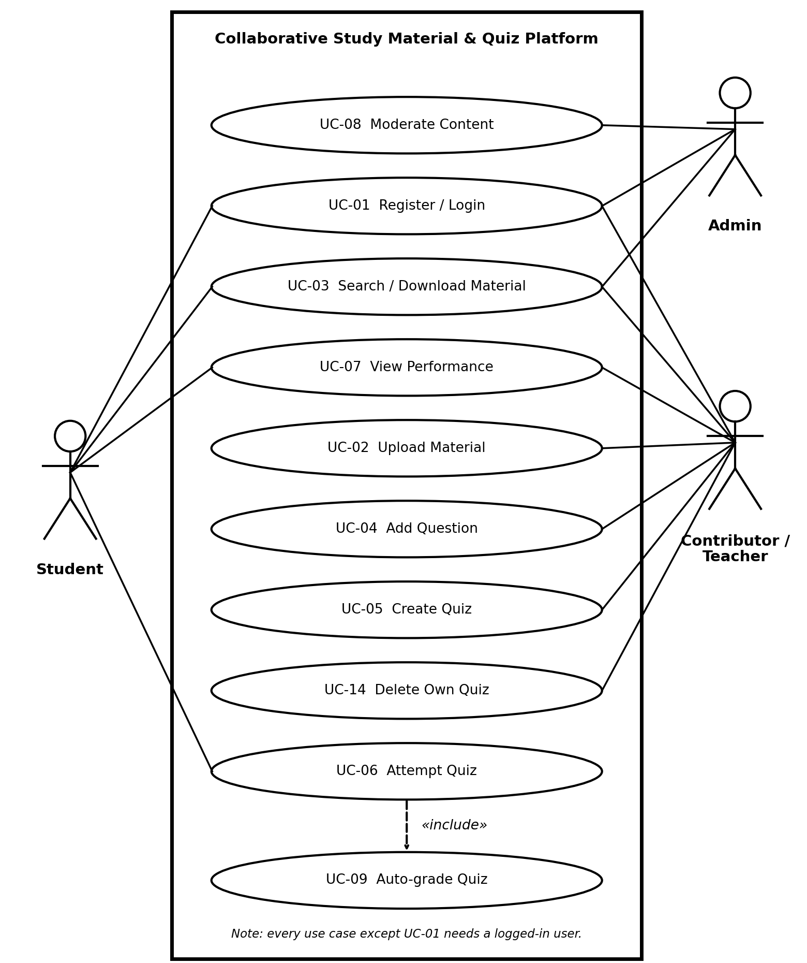
Figure 1: Use case diagram – system overview
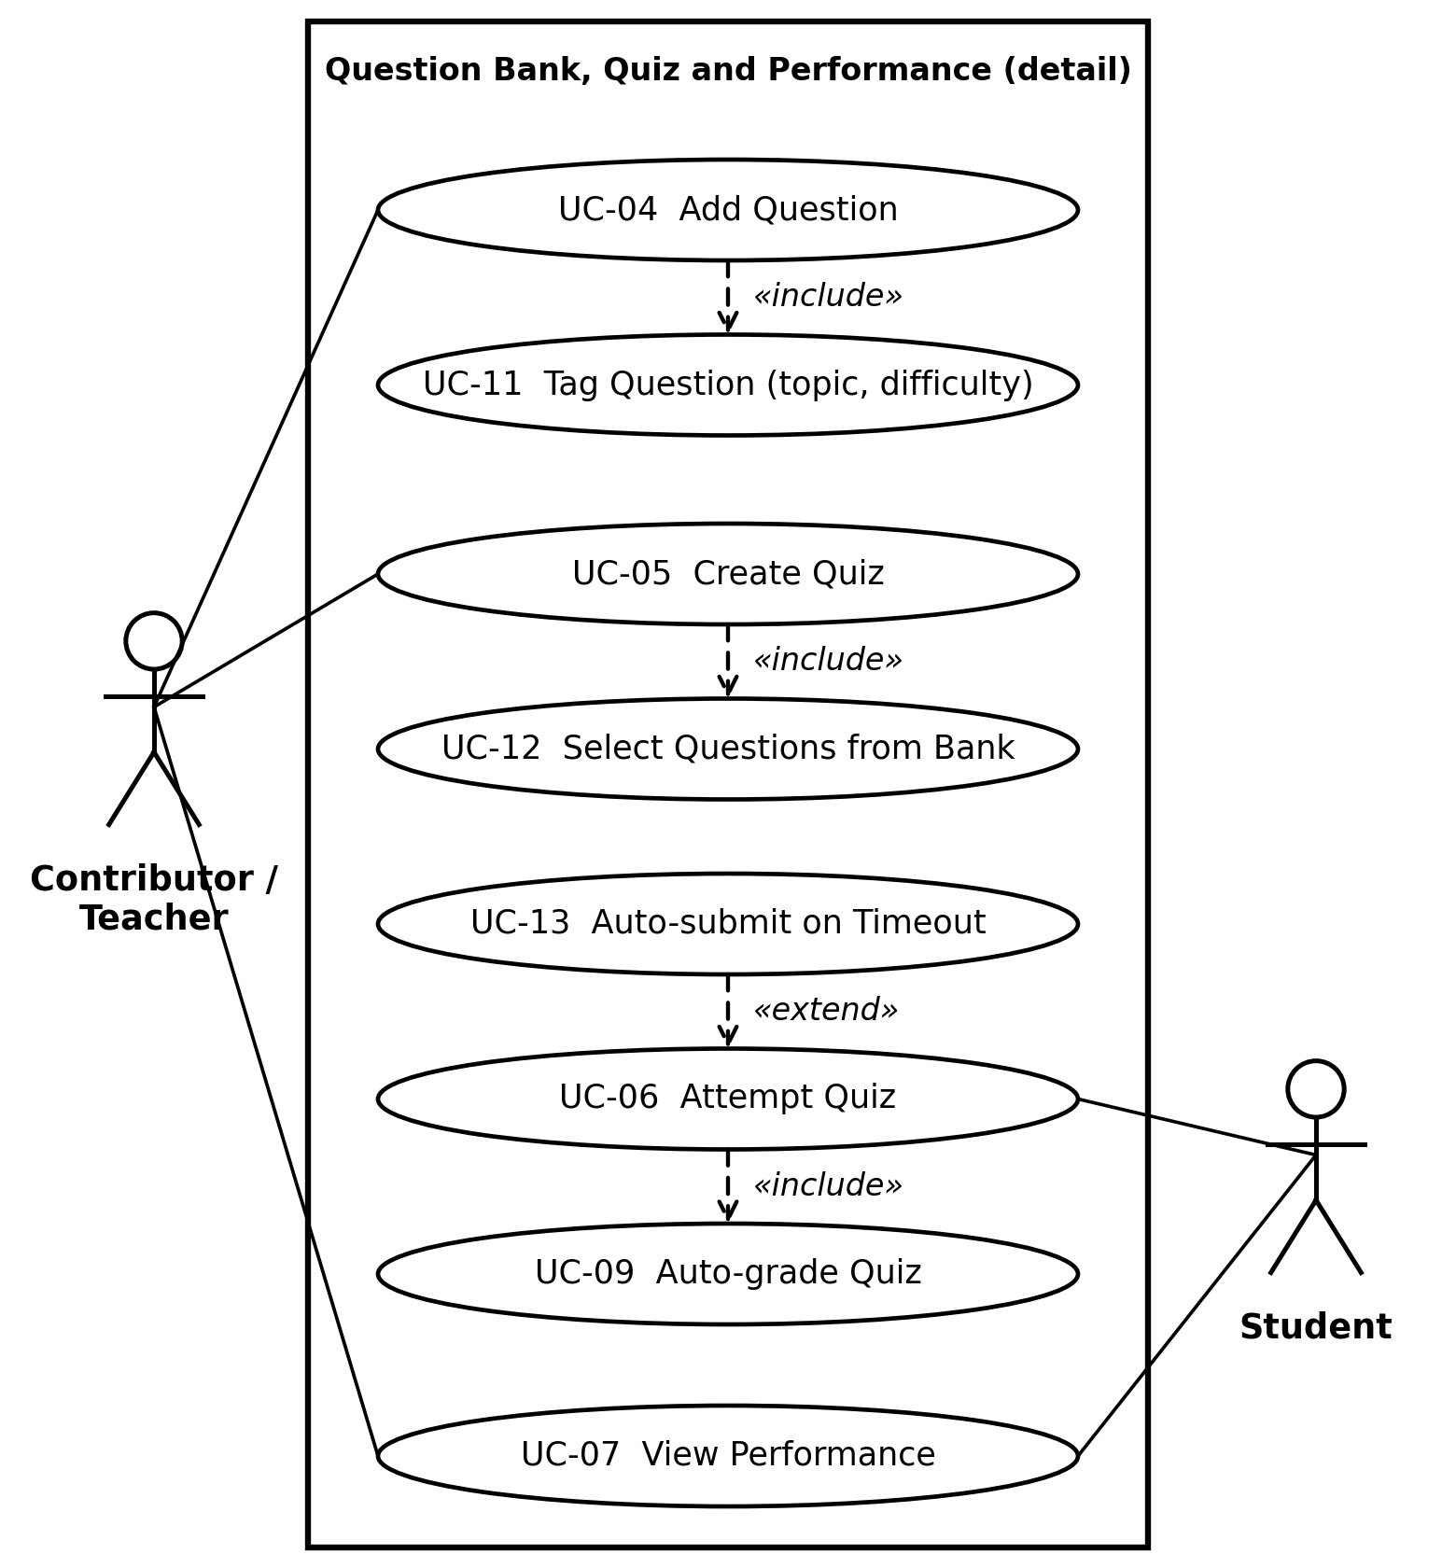
Figure 2: Use case diagram – question bank, quiz and performance (detail)

8. Requirements Traceability Matrix (RTM)
Status: N = Not started, P = Partly done, A = Achieved (implemented and test passed). The DS references point to the sections of the Software Architecture & Design Specification; the TC references point to the Test Plan.
Req ID | Requirement short | Section ref / Design Spec | Module | Test case(s) | Status (N/P/A) | Comments
CSQ-F-001 | User registration | 4.1 / DS-Auth-01 | Auth Module | TC-Auth-01 | N | UC-01
CSQ-F-002 | Login | 4.1 / DS-Auth-02 | Auth Module | TC-Auth-02 | N | UC-01
CSQ-F-003 | Role-based feature access | 4.1 / DS-Auth-03 | Auth Module | TC-Auth-03 | N | Table 1
CSQ-F-004 | Logout | 4.1 / DS-Auth-04 | Auth Module | TC-Auth-04 | N | UC-01
CSQ-F-005 | Password rule | 4.1 / DS-Auth-05 | Auth Module | TC-Auth-05 | N | UC-01
CSQ-F-010 | Upload material | 4.2 / DS-Mat-01 | Material Module, File Storage | TC-Mat-01 | N | UC-02
CSQ-F-011 | Search material | 4.2 / DS-Mat-02 | Material Module | TC-Mat-02 | N | UC-03
CSQ-F-012 | Download material | 4.2 / DS-Mat-03 | Material Module, File Storage | TC-Mat-03 | N | UC-03
CSQ-F-020 | Add question | 4.3 / DS-QB-01 | Question Bank Module | TC-QB-01 | N | UC-04
CSQ-F-021 | Edit / delete own question | 4.3 / DS-QB-02 | Question Bank Module | TC-QB-02 | N | UC-04
CSQ-F-022 | Tag and filter questions | 4.3 / DS-QB-03 | Question Bank Module | TC-QB-03 | N | UC-04, UC-05
CSQ-F-030 | Create and publish quiz | 4.4 / DS-Quiz-01 | Quiz Module | TC-Quiz-01 | N | UC-05
CSQ-F-031 | Attempt quiz with timer | 4.4 / DS-Quiz-02 | Quiz Module, React Frontend | TC-Quiz-02 | N | UC-06
CSQ-F-032 | Auto-grade and show result | 4.4 / DS-Quiz-03 | Quiz Module | TC-Quiz-03 | N | UC-06
CSQ-F-033 | List published quizzes | 4.4 / DS-Quiz-04 | Quiz Module, React Frontend | TC-Quiz-04 | N | UC-06
CSQ-F-034 | Delete own quiz | 4.4 / DS-Quiz-05 | Quiz Module | TC-Quiz-05 | N | UC-14
CSQ-F-040 | Student performance page | 4.5 / DS-Rep-01 | Performance Module | TC-Rep-01 | N | UC-07
CSQ-F-041 | Contributor quiz statistics | 4.5 / DS-Rep-02 | Performance Module | TC-Rep-02 | N | UC-07
CSQ-F-050 | Remove material / quiz | 4.6 / DS-Adm-01 | Backend Server (Admin routes) | TC-Adm-01 | N | UC-08
CSQ-NF-001 | Search within 2 s | 5 / DS-Perf-01 | Material Module, MongoDB | TC-Perf-01 | N | Perf.
CSQ-NF-002 | Result within 3 s | 5 / DS-Perf-02 | Quiz Module | TC-Perf-02 | N | Perf.
CSQ-NF-003 | 99% availability | 5 / DS-Ops-01 | Backend Server | TC-Ops-01 | N | Uptime report
CSQ-NF-004 | Usability trial | 5 / DS-UX-01 | React Frontend | TC-UX-01 | N | 10 users
CSQ-NF-005 | Browser / screen support | 5 / DS-UX-02 | React Frontend | TC-Comp-01 | N | 4 browsers
CSQ-NF-006 | Page load within 3 s | 5 / DS-Perf-03 | React Frontend | TC-Perf-03 | N | Perf.
CSQ-NF-007 | Daily backup, restore ≤ 4 h | 5 / DS-Ops-02 | MongoDB Database | TC-Ops-02 | N | Restore drill
CSQ-SR-001 | Password hashing (bcrypt) | 5.1.2 / DS-Sec-01 | Auth Module | TC-Sec-01 | N | SO-01
CSQ-SR-002 | Role check on every request | 5.1.2 / DS-Sec-02 | Backend Server (middleware) | TC-Sec-02 | N | SO-02
CSQ-SR-003 | Reject invalid session token | 5.1.2 / DS-Sec-03 | Auth Module | TC-Sec-03 | N | SO-01, SO-02
CSQ-SR-004 | File type and size checks | 5.1.2 / DS-Sec-04 | Material Module, File Storage | TC-Sec-04 | N | SO-02
CSQ-SR-005 | HTTPS (TLS 1.2+) | 5.1.2 / DS-Sec-05 | Backend Server, React Frontend | TC-Sec-05 | N | SO-01
CSQ-SR-006 | Audit log entries | 5.1.2 / DS-Sec-06 | Backend Server, MongoDB | TC-Sec-06 | N | SO-03
CSQ-SR-007 | Server-side input validation | 5.1.2 / DS-Sec-07 | Backend Server (validation) | TC-Sec-07 | N | SO-02

Totals: 19 functional requirements, 7 non-functional requirements, 3 security objectives, 7 security requirements and 13 use cases. Every requirement has at least one test case reference.

